**GOVARDHANAN .K.S**

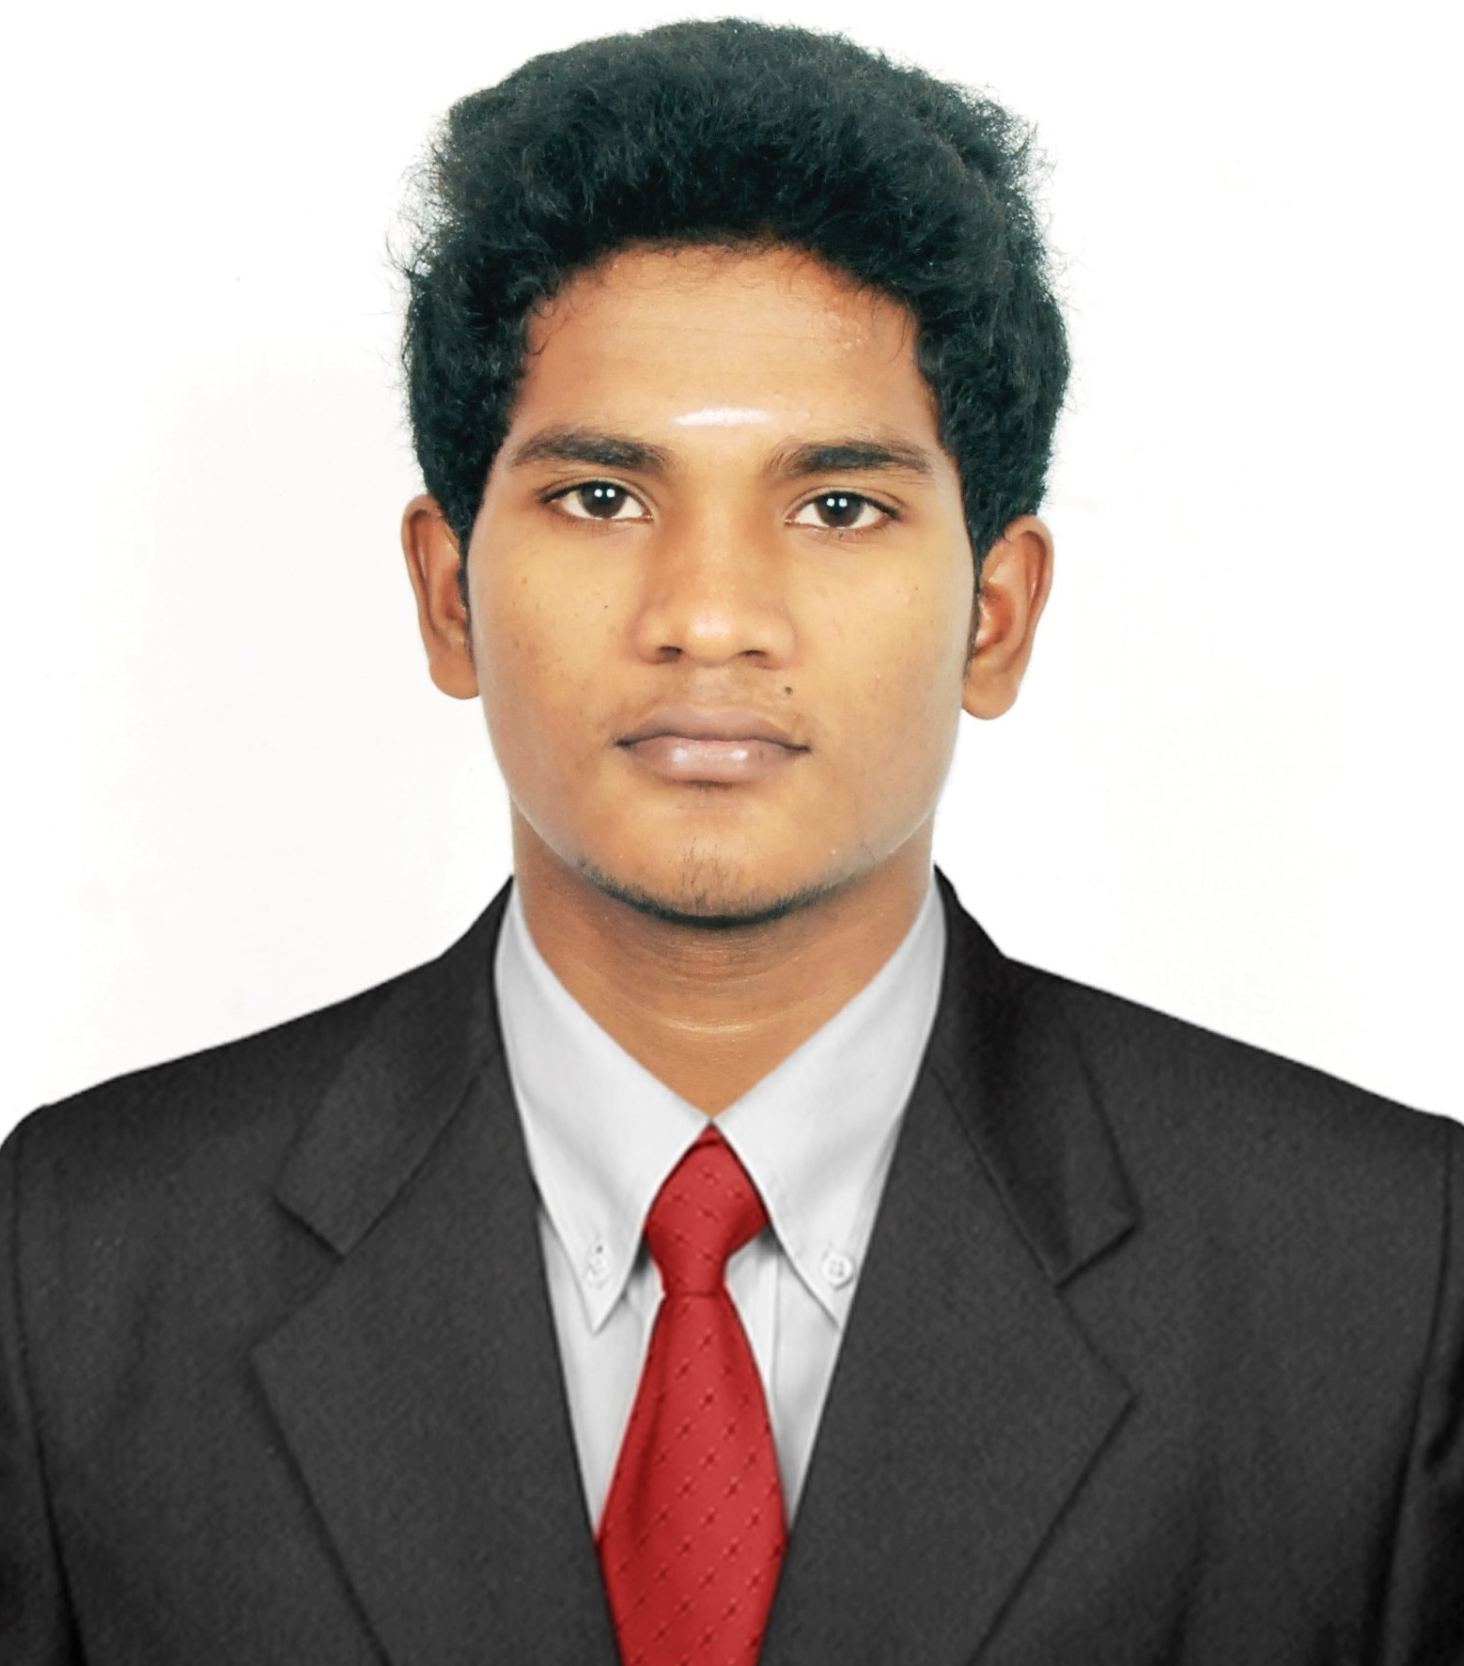

**S/o SRIRAMLU .K**

**NO.11/20 Araganatha puram Street**

**Chetpet**

**Chennai 600 031**

**Mobile No: 8220286068**

**Email:** [**ksgovardhanan1@gmail.com**](mailto:ksgovardhanan1@gmail.com)

**Github:**Govardhanan1705207

**OBJECTIVE**

To obtain a challenging position in our organization and improve my skill.

**EDUCATIONAL QUALIFICATION**

|  |  |  |  |  |
| --- | --- | --- | --- | --- |
| **Degree/ Course** | **Name of Institution / Place** | **University / Board** | **Year of Passing** | **Percentage/**  **CGPA** |
| BE.CSE | Coimbatore Institute of Technology Coimbatore -641014 | Anna University | Pursuing | 6.94  (upto 5th sem) |
| DECE | Panimalar Polytechnic College,  Chennai- 29 | DOTE, Chennai | 2017 | 93% |
| HSC | Sri Ramakrishana Mession Boy’s Higher Secondary School,  Chengalpattu 603001 | State Board | 2015 | 52.2% |
| SSLC | Sri Ramakrishana Mession Boy’s Higher Secondary School,  Chengalpattu 603001 | State Board | 2013 | 81.6% |

**PROJECT:**

* + Prepaid Electronic Toll collection system, using Embedded hardwares(2017).
  + Mini project :Blockchain Enable E-voting.

**WORK EXPERIENCE:**

**ACT (**Atria convergence Technologies Pvt Ltd) 2017(june).

**TRAINING AND CERTIFICATION**

* **BSNL(2017)**

Network concept & Ip addressing, Cisco Router configuration, Hands on training in optical fiber cable splicing.

* **BLACK FLUX**

Junior Developer Intern and assisted in our development Team.

**AREAS OF INTEREST:**

* Networking
* Embedded
* Software application UI development

**STRENGTH:**

* Leadership
* Adaptability

**HOBBIES:**

* Browsing new Technology in Internet.
* Swimming, playing chess.

**PERSONAL DETAILS**

Name : Govardhanan. k.S

Father’s name : Sriramalu .k

Date of Birth : 08-06-1997

Age : 21

Languages Known : Tamil, English, Telugu

Permanent address : NO.1/39 Marryaman koil Street

Anoor village & Anoor post

Chengalpattu Kanchipuram (Dist) 603405.

Mobile No: 8220286069

Email: [ksgovardhanan1@gmail.com](mailto:ksgovardhanan1@gmail.com)

# DECLARATION

I hereby assure that all the information provided above are true to the best of my knowledge and belief.

**PLACE: Coimbatore**

**DATE : [GOVARDHANAN .K.S]**